MedBook

Use-Case Specification

Version <1.0>

Revision History

| **Date** | **Version** | **Description** | **Author** |
| --- | --- | --- | --- |
| 12/11/21 | 1.0 | Complete sections 1, 2 | NPVy, NPChien, NNDu, HNMDuc, NKTTNga |
|  |  |  |  |
|  |  |  |  |
|  |  |  |  |

Table of Contents

1. **Use-case Model** **4**
2. **Use-case Specifications** **5**

**2.1** **Use-case: Log in** **5**

**2.2** **Sign up** **5**

**2.3** **Forget password** **5**

**2.4** **Booking** **6**

**2.5** **View Appointments** **6**

**2.6** **Edit Appointments** **7**

**2.7** **Profile** **7**

**2.8** **News** **7**

**2.9** **Follow-up examination** **8**

**2.10** **View hospital and doctor info** **8**

# Use-case Model

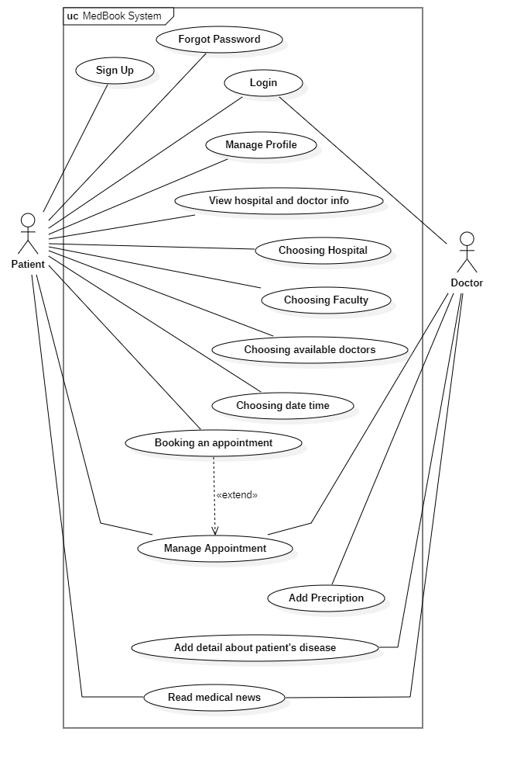

# Use-case Specifications

## Use-case: Log in

| **Use case Name** | Log in |
| --- | --- |
| **Brief description** | This use case describes how the Patients/Doctors can access some personalized features. |
| **Actors** | Patient/Doctor |
| **Basic Flow** | 1. Users must prepare for the internet connection (3G/4G/Wifi). 2. Users open the app. 3. Users go to the Account tab then scroll to the bottom of this tab. 4. Users use the pre-registered account or click on G logo to use Google Account to log in or click on F logo to use Facebook to login. 5. Users can use all the features in our app. |
| **Alternative Flows** | **Alternative flow 1: The user input wrong username or password**   1. Users still stay in the login tab and can not use any personalized features.   **Alternative flow 2: Users use Google/Facebook accounts to login to our app but that account has not been connected to our app.**   1. A new account will be created and attached to that Google/Facebook account and use the information of that Google/Facebook account to create a new account. |
| **Pre-conditions** | Users have an internet connection and open the Account tab then scroll to the bottom of this tab. |
| **Post-conditions** | Users can use all the features in our app. |

## Sign up

| **Use case Name** | Sign up |
| --- | --- |
| **Brief description** | This use case describes how the Patient can create a new account to use all the features. |
| **Actors** | Patient |
| **Basic Flow** | 1. Users click on the Register tag at the bottom of the Login page. 2. Users enter the email. 3. Users enter their password they want to use (password must have more than or equal 6 characters). 4. Users re-enter the password they typed in step 3. 5. Click Register button |
| **Alternative Flows** | **Alternative flow 1: User enters the password which length is shorter than 6**   1. Users will be redirected to the Register page then they must choose a new password.   **Alternative flow 2: the password in the Password box and Confirmed-password box are not the same.**   1. Users can not register to our service, they need to make sure the 2 passwords are the same.   **Alternative flow 3: the email is registered in the past.**   1. Users must choose another mail or use the Forget password feature. |
| **Pre-conditions** | Users must be in the Login page. |
| **Post-conditions** | Users have an account to use all the features of our service. |

## Forget password

| **Use case Name** | Forget password |
| --- | --- |
| **Brief description** | This use case describes how the Patient can reset their password when forgetting it. |
| **Actors** | Patient |
| **Basic Flow** | 1. User clicks on *Forgot Password* on the Login page. 2. User enters his/her phone number which is used as username account. 3. The system sends reset-password link to the email linked to the account of user. 4. User receives an email with link for reset-pass and clicks on it. 5. User enters new password and clicks confirm button. 6. User is informed that password is reset successfully. |
| **Alternative Flows** | **Alternative flow 1: User cannot remember the registered email**   1. From step #2 of the basic flow, user clicks on the button *Send-OTP-through-SMS.* 2. System sends OTP code to user’s phone number. The OTP code will be valid within 15 seconds. 3. User enters OTP code to verify resetting process. 4. Continue with step #5. |
| **Pre-conditions** | User download and open the app. |
| **Post-conditions** | The user successfully reset password and move back to the login page for continuing. |

## Booking

| **Use case Name** | Booking appointment |
| --- | --- |
| **Brief description** | This use case describes how the Patient can view doctor’s schedule and book appointments through MedBook. |
| **Actors** | Patient |
| **Basic Flow** | 1. From the home page, User click on the *Booking* button. 2. User choose which city he/she can go to from City Filter. 3. User pick one hospital from the hospital list ( These hospitals are located in the selected city). 4. User chooses facilities such as ( Heart, Surgery,...). 5. User will receive a list of doctors who belong to the chosen hospital. 6. User chooses a doctor to view schedule. 7. User picks day and time for the appointment. 8. User clicks on *Make-appointment* button to finish booking process. |
| **Alternative Flows** | **Alternative flow 1: The user makes a reservation for an already scheduled appointment**   1. Continue with step #8 from the basic flow, the patient is informed that the selected appointment was already made before. 2. User clicks on *Back* button to reselect another appointment. |
| **Pre-conditions** | Users go to the homepage of MedBook application. |
| **Post-conditions** | The users successfully make appointments with their appropriate doctors and propitious timing. |

## View Appointments

| **Use case Name** | View appointments |
| --- | --- |
| **Brief description** | This use case describes how the Patient can view their appointment list. |
| **Actors** | Patient |
| **Basic Flow** | 1. Click on the Appointment button. 2. System displays Appointments list on two tabs: one for Incoming events and one for Done events. 3. Users click on one of two tabs to view the appointments list. 4. Users choose a specific appointment to view its information. 5. System displays details of meeting date and time, doctor, hospital, and status belonging to the selected appointment. |
| **Pre-conditions** | Users go to the homepage of MedBook application. |
| **Post-conditions** | The users can review both Incoming events and Done events. |

## Edit Appointments

| **Use case Name** | Edit appointments |
| --- | --- |
| **Brief description** | This use case describes how the Patient can edit their Incoming appointments. |
| **Actors** | Patient |
| **Basic Flow** | 1. User clicks on the *Appointment* button. 2. User clicks on tab Incoming. 3. User clicks on the appointment that will be modified. 4. Choose the *Edit* button. 5. Select date and time or *Cancel* this appointment. 6. Click on the *Save* button to finish the process. |
| **Pre-conditions** | Users go to the homepage of MedBook application. |
| **Post-conditions** | The user can review both edit date, time or cancel a determined appointment. |

## Profile

| **Use case Name** | Manage Profile |
| --- | --- |
| **Brief description** | This use case describes how the users can edit. |
| **Actors** | Patients |
| **Basic Flow** | 1. From the homepage, select ‘Profile’. 2. The system displays user’s profile for viewing. 3. On the profile page, select ‘Manage Profile’. 4. Select the information need to be edited. 5. After finishing editing, select ‘OK’ to update new information. 6. The system displays a new profile page with new information. |
| **Alternative Flows** | **Alternative flow 1: Require Confirmation**   1. From step #3 of the basic flow, if the user selects ‘ID card’ or ‘phone number’, after editing selects ‘*Send-OTP-through-SMS’* for confirmation. 2. The system sends an OTP code to the user’s phone number. The OTP code will be valid within 15 seconds. 3. The user enters the OTP code to verify the confirmation process. 4. Continue with step #4. |
| **Pre-conditions** | The user goes to the homepage on the MedBook application. |
| **Post-conditions** | The user successfully updates profile information. |

## News

| **Use case Name** | View medical news. |
| --- | --- |
| **Brief description** | This use case describes how the news page is viewed. |
| **Actors** | Patients / Doctors |
| **Basic Flow** | 1. From the homepage, select ‘News’ to access the News page. 2. The system displays new medical articles. 3. View articles by scrolling down the page. 4. Select the article that needed to be viewed in detail to read more about the medical problem. 5. The system displays the article in closer detail. |
| **Alternative Flows** | **Alternative flow 1: Article cannot be found.**   1. From step #3, the system displays ‘Article cannot be found’. 2. The system turns back to the News page. 3. Continue with step #3. |
| **Pre-conditions** | The user goes to the homepage on the MedBook application. |
| **Post-conditions** | The user successfully views new medical articles. |

## Follow-up examination

| **Use case Name** | Follow-up examination |
| --- | --- |
| **Brief description** | This use case describes how the follow-up examination process takes place. |
| **Actors** | Patients / Doctors |
| **Basic Flow** | 1. From the homepage, select ‘Appointment’ to access the Appointments page. 2. The system displays doctors’ schedules. 3. Select the date. 4. The system displays the list of appointments on the selected date. 5. Select the patient for the next appointment. 6. Select medicine and diseases. 7. Select ‘OK’ to confirm. 8. The system displays the newly created appointment. |
| **Alternative Flows** | **Alternative flow 1: Patient cannot be found**   1. From step #5, the system displays ‘Patient cannot be found’. 2. The system turns back to the Appointments page. 3. Continue with step #4. |
| **Pre-conditions** | The user goes to the homepage on the MedBook application. |
| **Post-conditions** | The doctor successfully creates new appointments. |

## View hospital and doctor info

| **Use case Name** | View hospital and doctor info |
| --- | --- |
| **Brief description** | This use case describes how Patients can view hospital and doctor information. |
| **Actors** | Patients |
| **Basic Flow** | 1. From the homepage, click on the Hospital button. 2. The system displays a list of hospitals. 3. Click on a hospital to view all its information. 4. The system displays the list of doctors who belong to the selected hospital. 5. Select a doctor to view his/her specialist. |
| **Alternative Flows** | **Alternative flow 1: Patient cannot find hospital or doctor**   1. Enter the name of hospital or doctor in the Search field. 2. The system displays hospital or doctor closed to that name. 3. Continue with step #3 from the Basic Flow. |
| **Pre-conditions** | The user goes to the homepage on the MedBook application. |
| **Post-conditions** | The patients successfully find and view hospital and doctor info. |